**Inheritance in java** is a mechanism in which a child class acquires all the properties and behaviors of a parent class. The aim of inheritance is to provide the reusability of code.

Child class can access parent class’s methods and variables.

We achieve inheritance using extends keyword. Example is in eclipse : InheritanceDemo, InheritanceDemo2.

**VVVIMP** : parent class reference can't access child class members and methods. And, Jya class cha object tya class chi method call hote.

**multiple inheritance :**

When one class extends more than one classes then this is called **multiple inheritance**. For example: Class C extends class A and B then this [type of inheritance](https://beginnersbook.com/2013/05/java-inheritance-types/) is known as multiple inheritance. Java **doesn’t** allow multiple inheritance.

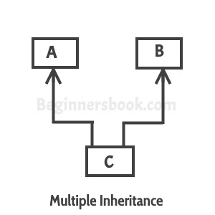

**multilevel inheritance :**

When a class extends a class, which extends another class then this is called **multilevel inheritance**. For example class C extends class B and class B extends class A then this [type of inheritance](https://beginnersbook.com/2013/05/java-inheritance-types/) is known as multilevel inheritance.  
Lets see this in a diagram:  
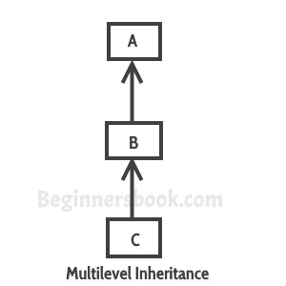

Can we overload a static method ? >> YES, we can. Static method overriding is nothing but method hiding.

**Exception handling and it’s impact on Inheritance :**

• **If the superclass method does not declare an exception**

* If the superclass method does not declare an exception, subclass overridden method cannot declare the checked exception but it can declare unchecked exception.

• **If the superclass method declares an exception**

* If the superclass method declares an exception, subclass overridden method can declare same, subclass exception or no exception but cannot declare parent exception.

# **What is method hiding in Java and how to use it?**

When super class and sub class contains same method including parameters and if they are static.

The method in the super class will be hidden by the one that is in the sub class. This mechanism is known as method hiding.

## Example

class Demo{

public static void demoMethod() {

System.out.println("method of super class");

}

}

public class Sample extends Demo {

public static void demoMethod() {

System.out.println("method of sub class");

}

public static void main(String args[] ) {

Sample.demoMethod();

}

}

## Output

method of sub class